Proposal

IoT Application for Refrigerator

MinA Jang

Advisor: Vanessa Aguiar

Submitted in partial fulfillment

Of the requirements of CSC-431

Software Engineering course project

2021-02-10

# Table of Contents

Prefaceiii

**0.0 Introduction1  
1.0 Overview2**

**1.1 Purpose, Scope and Objectives 2**

**1.2 Project Description 2**

**2.0 Reference3**

# Preface

This is a proposal for the “IoT Application for Refrigerator” project for partial fulfillment of the requirements of a Software Engineering course (CSC431) project in the department of Computer Science at the University of Miami.

This proposal provides the scope and context of the project to be undertaken. It details the intended user group and the value that the system will have to them.

The intended audience of this document is the course professor and teaching assistants so that they can determine whether the project should be approved as proposed, approved with modifications, or not approved.

# Introduction

Ever since the inception of “IoT: Internet of Things” in 1980s, there has been a steady increase in the use of smart objects. From Coca Cola vending machine that automatically sends sales reports to Amazon echo dot, the smart objects that enhance the efficiency of our lives have increasingly dominated our surroundings. According to Statista, the global trend of IoT spending has seen a steep growth in last five years, as shown in the figure 1.

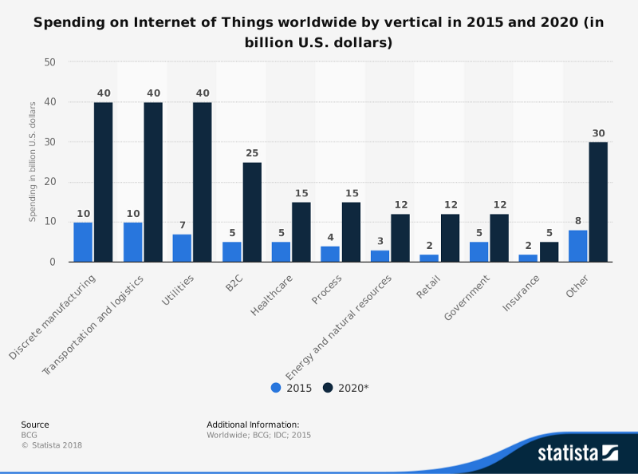

Figure

Moreover, the McKinsey reports expects the market of IoT to reach an annual economic impact of $3.9 trillion to $11.1 trillion by 2025. Bright prospect of IoT business can only be explained by the increased demand of smart objects. Such trend also indicates that there will be an upsurge of projects related to IoT in the future. Therefore, I(our team) have concluded that implementing a project to devise a smart refrigerator would be a suitable topic for the course.

# 1.0 Overview

## Purpose, Scope and Objectives

The purpose of this project is to provide an application for smart refrigerator so that the user can organize groceries more efficiently. It would be used in homes, restaurants and any other facilities that require food preparations.

## Project description

According to the study by Movinga, nearly one fourth of the food purchased by US household goes to waste. Although the statistics might be caused by many complex reasons, introducing a helpful hobby of keeping track of groceries and its expiration dates can aid in reducing the food waste.

* Storing grocery information:

Scanning a barcode of the receipt gives the application an access to the list of groceries purchased. The item information then is treated and saved so that it can serve the following purposes.

* Provide the list of food items with corresponding expiration date:

User can access the grocery list to find the corresponding purchase and expiration dates. Feature to notify about approaching expiration date.

* Recommend recipe with existing item:

Implement search facility so that the application recommend recipe that makes use of the existing item.

# 2.0 Reference

https://www.statista.com/statistics/666864/iot-spending-by-vertical-worldwide/  
https://www.mckinsey.com/business-functions/mckinsey-digital/our-insights/the-internet-of-things-the-value-of-digitizing-the-physical-world

https://www.statista.com/chart/15143/percieved-food-waste/